Scripting Task:

HTTP Statuscode Task:

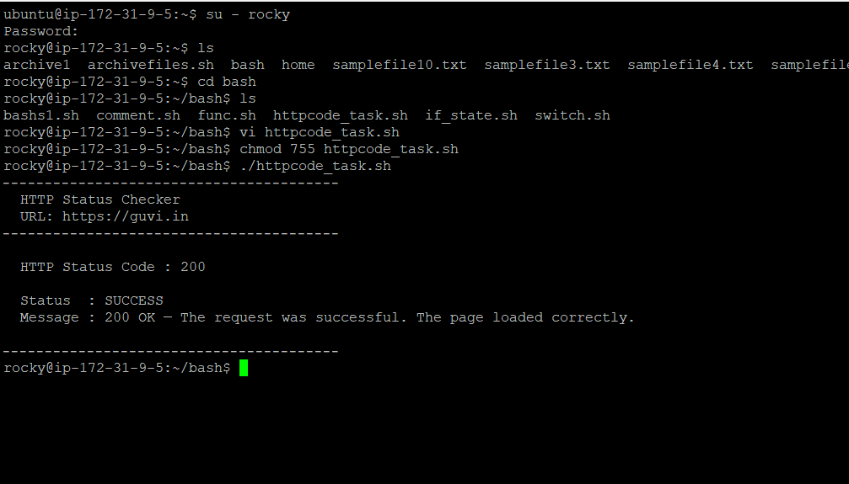

Find and replace task in the given file:
